Opus People Solutions – Quality Policy

Opus People Solutions are committed towards a Quality Policy that ensures we consistently meet Clients quality and reliability needs and expectations. We aim to achieve these in a safe, responsible, ethical, sustainable, and environmentally sound way, in accordance with our policies, procedures and the company’s strategic direction. We will actively promote and administer a strong Quality and Environmental culture amongst our staff and our sub-contractors.
Opus People Solutions was established in May 2014. We specialise in working with clients to provide cost effective, high quality end to end recruitment solutions either directly or via our managed service offering. With an expertise and heritage in Public and Not for Profit sectors, we have deep insight into how these organisations work which sets us apart in the market.
Our dedicated team has considerable experience in the recruitment industry, both in the private and public sector, with a track record of delivering successful solutions for our clients contingent resourcing needs. We are an experienced managed service provider and maintain a supply chain of over 100 recruitment agencies and contractors to enhance our service offering.
We provide a cost-effective professional recruitment service, including:
- Providing temporary workers to clients
- Offering a fully managed recruitment service
- Providing permanent recruitment support
- Supplying teachers and support staff into schools
- Tutoring services
- Outplacement support
A member of the Recruitment & Employment Confederation (REC), we operate to its Code of Conduct, all relevant government legislation and best industry practice assuring our clients of the highest ethical and compliance standards.
To assure our Quality Management objectives are realised, we have established a Management System incorporating the requirements of ISO9001:2015. The Company will assure the health, safety, and welfare of employees whilst at work in accordance with the Health & Safety at Work act 1974.
The Management Team are committed to the leadership, implementation, development and continuous improvement of the Management System, policies, work practices, procedures and competencies to meet the developing needs of our clients, regulatory, statutory and other requirements, including the aim to enhance customer satisfaction.
The Management Team will adopt a risk-based strategy to identify, assess and raise awareness of business and environmental risks and opportunities; implementing processes and procedures to prevent and mitigate negative risks whilst pursuing positive risk opportunities.
The communication of the Management Teams commitment to the management system is via this policy statement, publication of Company Policy, procedures, work instructions, and day to day communications. All employees are encouraged to participate in the development of the management systems and environmental processes including any relevant improvement projects.
Company policies, objectives and targets are established and reviewed during ‘Management Review’, upon establishment of the significant environmental impacts and initiatives. Objectives and obligations can also be established via legislation changes, periodically by Management directives and meetings, and for specific project works.

Information, training, equipment and supervision will be provided to employees according to task and business needs, in order to perform their duties competently and safely. All personnel shall work with consideration for the environment, and others who may be affected by their acts or omissions. All personnel shall work in agreed ways to prevent pollution and reduce environmental impacts.
Every employee is responsible for and will be trained to perform the duties required by their specific role. Implementing a QMS that demonstrates that all Opus staff are committed to continual improvement, customer care, staff wellbeing, equality, and diversity
It is the responsibility of management and employees to understand and apply this policy, associated procedures, practices and project specific documentation in all aspects of their responsibility areas and continue to maintain our high standards and reputation. This policy and associated procedures are monitored by internal and external audit and inspection.
This policy document will be made available to all staff, customers, and other relevant interested parties. It will be displayed prominently throughout Opus offices and our external website. It will be reviewed on a regular basis as part of the Management Review.
As Managing Director, I have overall responsibility for this policy and have allocated all necessary resources for its implementation and ongoing compliance.

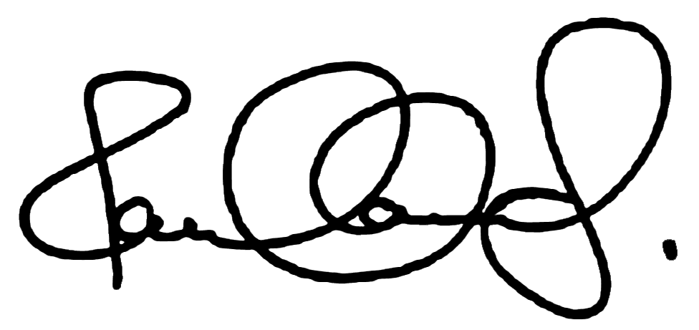

Paul Lowes
Managing Director Dated: 15/06/2020

